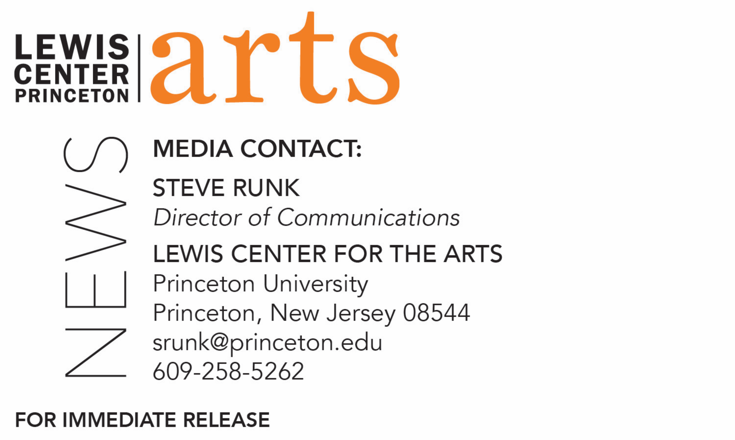

October __, 2022

**Lewis Center for the Arts’ Program in Visual Arts presents**

***HERE YE, HEAR YE!!!***

**Exhibition** **by artist and 2021-22 Hodder Fellow Mark Thomas Gibson of collages, paintings and poster work that engage satire to depict the subtext of American politics and life**

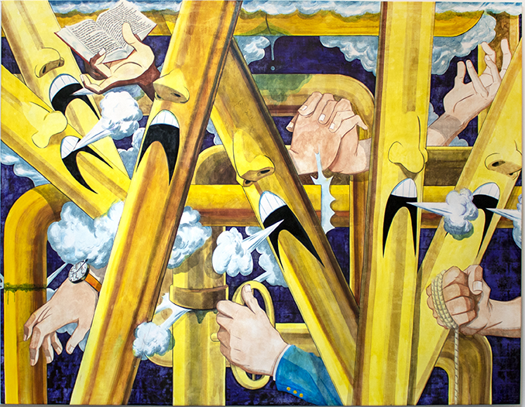 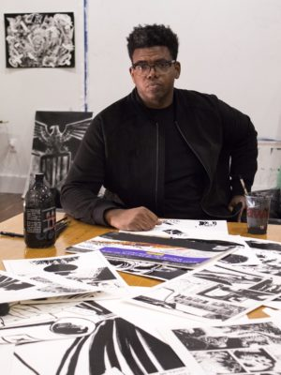

Photo caption 1: “Full Steam Ahead” (2022, ink on canvas), one of the works in Mark Thomas Gibson’s show, *HERE YE, HEAR YE!!!*

Photo credit 1: Courtesy of the artist

Photo caption 2: Mark Thomas Gibson

Photo credit 2: Kathryn Gegenheimer

What/Who: *HERE YE, HEAR YE!!!*, is an exhibition of new work created by Mark Thomas Gibson during the course of his 2021-22 Hodder Fellowship at Princeton. Gibson’s work engages satire to depict the subtext of American politics and life. The exhibition features collages, paintings and posters, all using varying degrees of caricature. For Gibson, caricature is a way to communicate his sentiments on his American community. As a Black man, Gibson’s viewpoint vacillates between participant and witness, but in these works the characters give him an uninterrupted voice to speak his opinions about contemporary political events. Presented by the Lewis Center for the Arts’ Program in Visual Arts.

When: On view October 27-November 23. Opening reception October 27 from 4:30-8 p.m. Artists’ talk November 17 at 4:30 p.m.

Where: Hurley Gallery at Lewis Arts complex on the Princeton University campus (

Gallery Hours: Daily from 10 a.m. - 8 p.m.

Admission:Free and open to the public; no tickets are required. All guests must either be fully vaccinated, or have recently tested negative and be prepared to show proof if asked, or wear a face covering when indoors and around others.

Accessibility: The Hurley Gallery is an accessible venue. Guests in need of access accommodations are invited to contact the Lewis Center at [LewisCenter@princeton.edu](mailto:LewisCenter@princeton.edu) at least one week prior to the event date.

For more information: <https://arts.princeton.edu/events/here-ye-hear-ye-an-exhibition-by-mark-thomas-gibson/2022-10-27/>

(Princeton, NJ) The Lewis Center for the Arts’ Program in Visual Arts at Princeton University will present *HERE YE, HEAR YE!!!,* an exhibition of new work created by Mark Thomas Gibson during the course of his 2021-22 Hodder Fellowship at Princeton. Gibson’s work engages satire to depict the subtext of American politics and life. The exhibition features collages, paintings and posters, all using varying degrees of caricature.The work will be on view October 27 through November 23 in the Hurley Gallery at the Lewis Arts complex on the Princeton campus. The exhibition will open with a reception in the gallery on October 27 from 4:30 to 8:00 p.m. An artists’ talk with Gibson and writer/curator Dan Nadel and painter/writer Amy Sillman is scheduled for November 17 at 4:30 p.m. in the gallery. All events are free and open to the public.

Gibson notes his personal lens on American culture stems from his multipartite viewpoint as an artist—as a Black male, a professor, and an American history buff. These myriad and often colliding perspectives fuel his exploration of contemporary culture through languages of painting and drawing, revealing a vision of a dystopic America where every viewer is implicated as a potential character within the story.

Gibson received a 2021 Pew Fellowship and a 2022 Guggenheim Fellowship. In 2016 he co-curated the traveling exhibition *Black Pulp!* with William Villalongo. He has released two books,*Some Monsters Loom Large* (2016) and *Early Retirement* (2017). Gibson received his B.F.A. from The Cooper Union in 2002 and his M.F.A. from Yale School of Art in 2013. He is represented by Fredericks & Freiser in New York, M+B in Los Angeles and Loyal in Stockholm. He is currently an assistant professor at Tyler School of Art and Architecture at Temple University and lives and works in Philadelphia.

For Gibson, caricature is a way to communicate his sentiments on his American community. As a Black man, he notes his viewpoint vacillates between participant and witness, but in these works the characters give him an uninterrupted voice to speak his opinions about contemporary political events. Gibson originally conceived *HERE YE, HEAR YE!!!* as an examination of the early Biden presidency but quickly felt that events beyond the presidency are the main attraction. The title of the exhibition is a declaration of shared place and time and an acknowledgement of how grotesque he views these times. One part town crier, one part Twitter feed, one part government protester, and one part inner monologue, Gibson’s work visualizes the stream going on inside all our heads as we try to navigate life in a heavily mediated world.

Moore was among five 2021-22 Hodder Fellows, artists chosen each year who demonstrate great promise and “much more than ordinary intellectual and literary gifts.” The support is intended to allow the selected artists to pursue an independent project with no requirement to be on the Princeton campus.

In addition to the exhibition’s opening on October 27, Gibson has invited Dan Nadel and Amy Sillman to join him in a conversation on November 17 on [possibly a sentence here on the general topic of the discussion?]. Nadel is an arts writer, curator-at-large of the Jan Shrem and Maria Manetti Shrem Museum of Art at the University of California, Davis, and former editor of *The Comics Journal*. Sillman is a writer and artist known for her process-based paintings that move between abstraction and figuration, and engage nontraditional media including animation, ‘zines and installation.

The Hurley Gallery is an accessible venue on the mezzanine level of the Lewis Arts Complex, reachable via the Arts Tower elevator. Guests in need of access accommodations are invited to contact the Lewis Center at [LewisCenter@princeton.edu](mailto:LewisCenter@princeton.edu) at least one week prior to the event date.

All guests must either be fully vaccinated, or have recently tested negative (via PCR within 72 hours or via rapid antigen test within 8 hours of the scheduled visit) and be prepared to show proof if asked, or wear a face covering when indoors and around others.

For more information on this event, the Program in Visual Arts, Hodder Fellowships, or any of the more than 100 performances, exhibitions, readings, screenings and lectures presented annually by the Lewis Center for the Arts, most of them free, visit [arts.princeton.edu](http://arts.princeton.edu/).

###